**XSLT Examples**

**Book.xml**

<?xml version="1.0" encoding="UTF-8"?>

<?xml-stylesheet type="text/xsl" href="xbook3.xsl"?>

<bookstore>

<book category="cooking">

<title lang="en">Everyday Italian</title>

<author>Giada De Laurentiis</author>

<year>2005</year>

<price>30</price>

</book>

<book category="children">

<title lang="en">Harry Potter</title>

<author>J K. Rowling</author>

<year>2005</year>

<price>29</price>

</book>

<book category="web">

<title lang="en">XQuery Kick Start</title>

<author>James McGovern</author>

<author>Per Bothner</author>

<author>Kurt Cagle</author>

<author>James Linn</author>

<author>Vaidyanathan Nagarajan</author>

<year>2003</year>

<price>49</price>

</book>

<book category="web">

<title lang="en">Learning XML</title>

<author>Erik T. Ray</author>

<year>2003</year>

<price>39</price>

</book>

<book category="IP">

<title lang="en">Learning IPL</title>

<author>Erik T. Ray</author>

<year>2003</year>

<price>39</price>

</book>

<book category="Literature">

<title lang="tamil">Ponniyin Selvan</title>

<author>Kalki</author>

<year>1950</year>

<price>390</price>

</book>

</bookstore>

1. **Retrieve the title and author of all the books**

**Book.xsl**

<?xml version="1.0" encoding="ISO-8859-1"?>

<xsl:stylesheet version="1.0" xmlns:xsl="http://www.w3.org/1999/XSL/Transform">

<xsl:template match="/">

<html>

<body>

<h2>My Book Collection</h2>

<table border="1">

<tr><th>Title</th><th>Author</th></tr>

**<xsl:for-each select="bookstore/book">**

**<tr><td><xsl:value-of select="title"/></td>**

**<td><xsl:value-of select="author"/></td></tr>**

**</xsl:for-each>**

</table>

</body>

</html>

</xsl:template>

</xsl:stylesheet>

**Output**

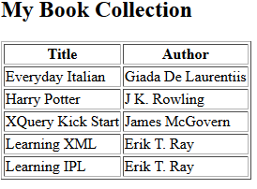

1. **Retrieve the title and author of books under “cooking” category**

**<xsl:for-each select="bookstore/book[@category=’cooking’]">**

**<tr><td><xsl:value-of select="title"/></td>**

**<td><xsl:value-of select="author"/></td></tr>**

**</xsl:for-each>**

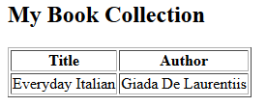

1. **Retrieve the title and author of books under “web” category**

**<xsl:for-each select="bookstore/book[@category=’cooking’]">**

**<tr><td><xsl:value-of select="title"/></td>**

**<td><xsl:value-of select="author"/></td></tr>**

**</xsl:for-each>**

**Output**

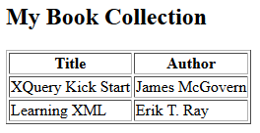

1. **Retrieve the title and author of first book**

**<xsl:for-each select="bookstore/book[1]">**

**<tr><td><xsl:value-of select="title"/></td>**

**<td><xsl:value-of select="author"/></td></tr>**

**</xsl:for-each>**

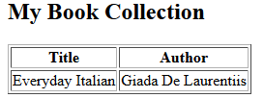

1. **Retrieve the title and author of last book**

**<xsl:for-each select="bookstore/book[last()]">**

**<tr><td><xsl:value-of select="title"/></td>**

**<td><xsl:value-of select="author"/></td></tr>**

**</xsl:for-each>**

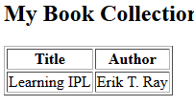

1. **Retrieve the title and author of last book**

**<xsl:for-each select="bookstore/book[last()-1]">**

**<tr><td><xsl:value-of select="title"/></td>**

**<td><xsl:value-of select="author"/></td></tr>**

**</xsl:for-each>**

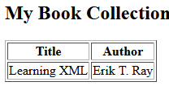

1. **Retrieve the title and author of last book**

**<xsl:for-each select="bookstore/book[position()&lt;3]">**

**<tr><td><xsl:value-of select="title"/></td>**

**<td><xsl:value-of select="author"/></td></tr>**

**</xsl:for-each>**

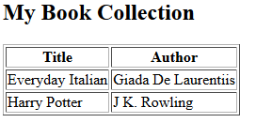

1. **Retrieve the books authored by “kalki”**

**<xsl:for-each select="bookstore/book[author=’kalki’]">**

**<tr><td><xsl:value-of select="title"/></td>**

**<td><xsl:value-of select="author"/></td></tr>**

**</xsl:for-each>**

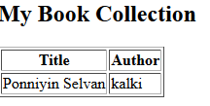

1. **Retrieve the title and author of tamil books**

**<xsl:for-each select="bookstore/book[author=’kalki’]">**

**<tr><td><xsl:value-of select="title"/></td>**

**<td><xsl:value-of select="author"/></td></tr>**

**</xsl:for-each>**

1. **Retrieve the title and author of books whose price is less than 30**

**<xsl:for-each select="bookstore/book[author=’kalki’]">**

**<xsl:if test=”price&lt;30”>**

**<tr><td><xsl:value-of select="title"/></td>**

**<td><xsl:value-of select="author"/></td></tr>**

**</xsl:if>**

**</xsl:for-each>**

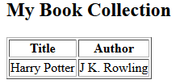

1. **Sort the books based on year**

**<xsl:for-each select="bookstore/book[author=’kalki’]">**

**<xsl:sort select=”year”/>**

**<tr><td><xsl:value-of select="title"/></td>**

**<td><xsl:value-of select="author"/></td></tr>**

**</xsl:for-each>**

